**Genre-Specific Audience Insights Report -Entertainment Sector**

Pooja Joshi & E.Code [E25007]

# Overview :

This report details the analysis and insights obtained from the **Genre-Specific Audience Insights** task, focusing on examining audience engagement levels, attendance rates, and sentiment. The primary goal was to create audience categories based on engagement metrics, perform clustering to uncover additional segments, and identify relationships between key metrics to assist in optimizing content strategy.

# Objective:

* To identify insights related to audience engagement, attendance, and sentiment using behavioral proxies for genre-specific audience insights.

# Assigned Task(s) :

* **Analyze audience behavior** using engagement levels and frequency cap as proxies for genre affinity.
* **Cluster audience segments** based on attendance and sentiment.
* **Perform correlation analysis** to assess relationships between key metrics.

# Task Details :

**Task 1**: Data Analysis & Audience Segmentation

* + **Status**: Completed
  + **Details**: We categorized audience types (Core, Casual, Occasional) based on engagement metrics and calculated mean attendance and sentiment scores for each category to understand audience engagement.

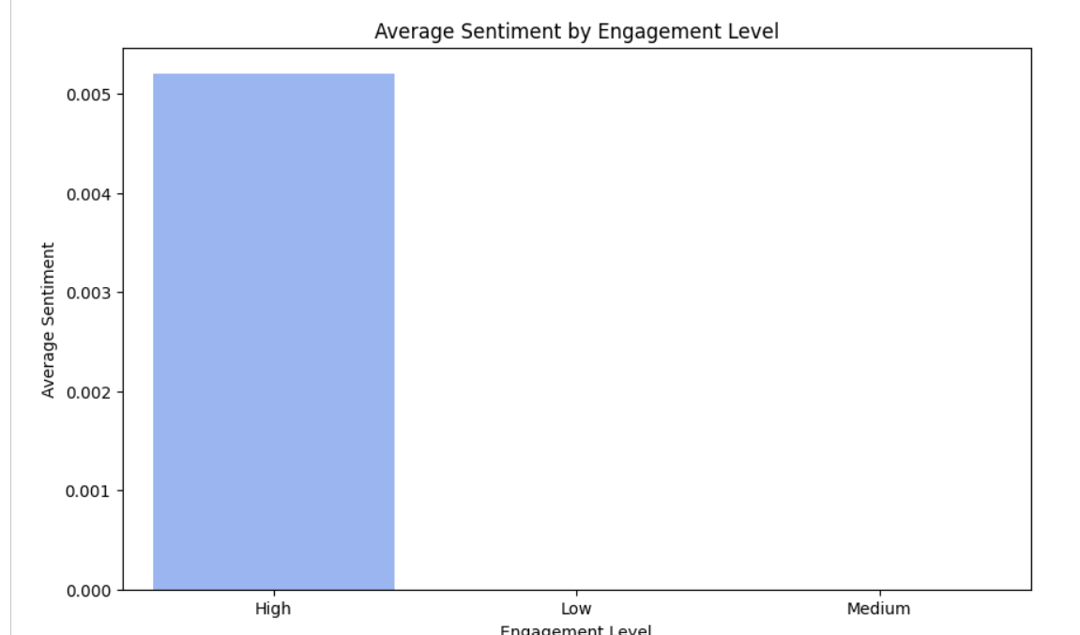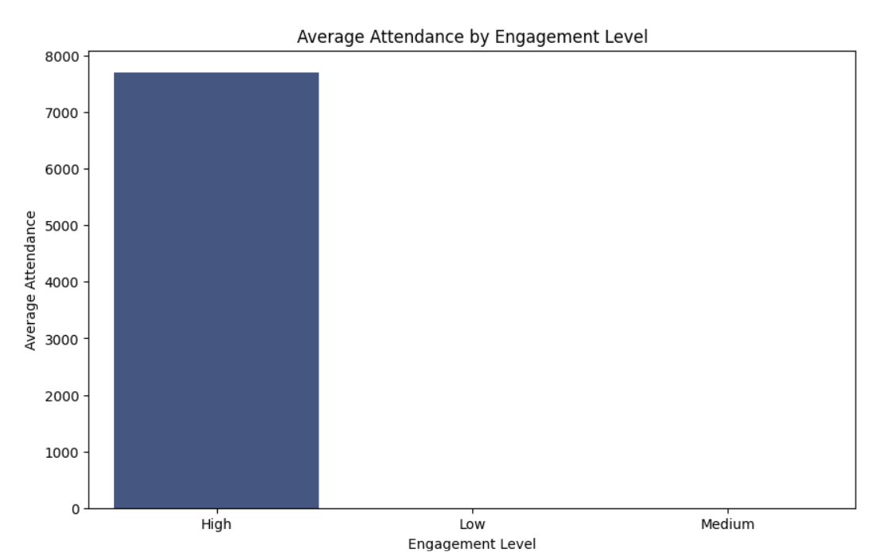

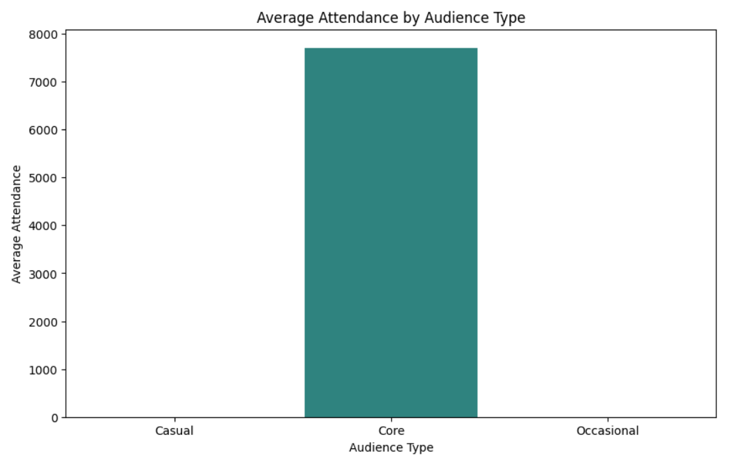

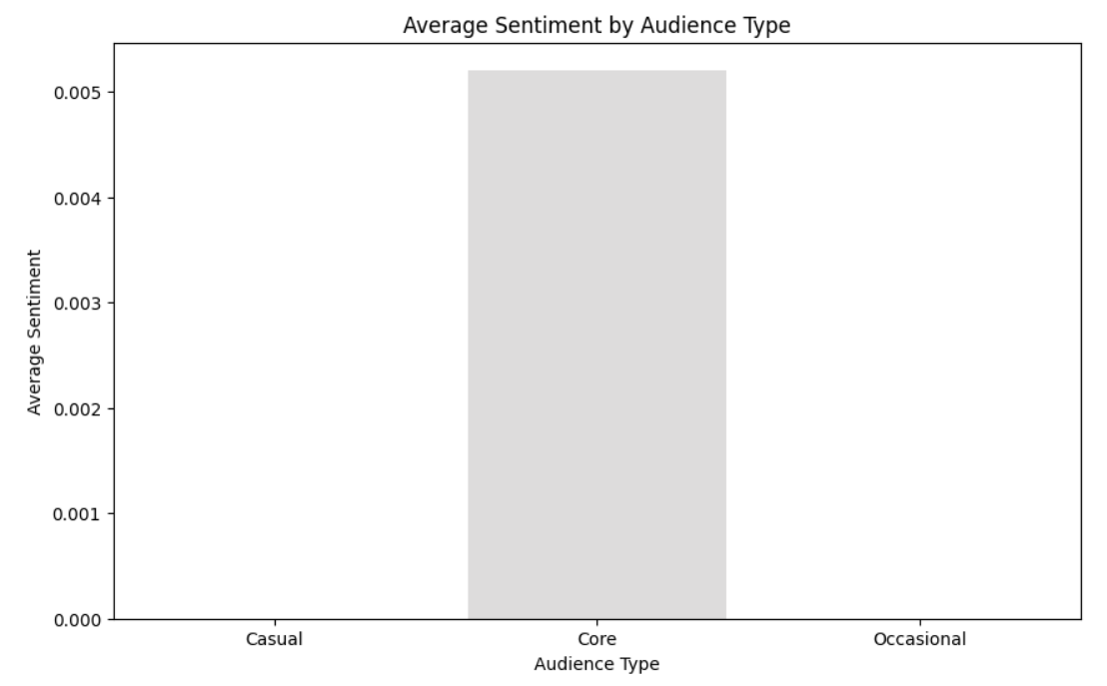

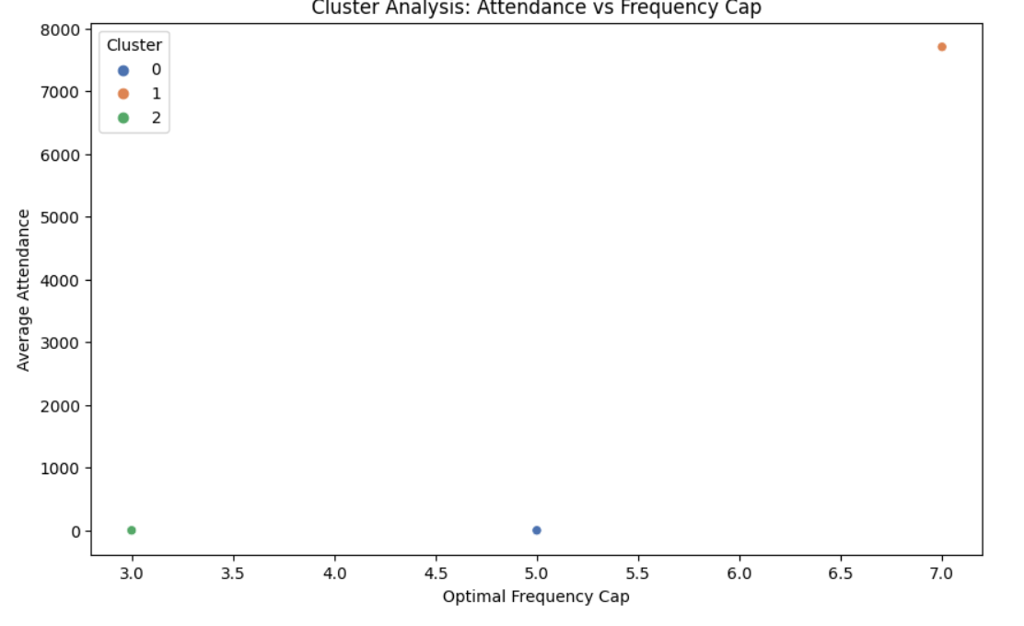

**Task 2**: Clustering Analysis

* + **Status**: Completed
  + **Details**: Performed K-Means clustering using Optimal Frequency Cap, Average Sentiment, and Average Attendance to uncover audience segments with similar behaviors. Three clusters were identified, which offer insights into distinct audience patterns.

**Task 3**: Correlation Analysis

* + **Status**: Completed
  + **Details**: Conducted correlation analysis between Optimal Frequency Cap, Average Sentiment, and Average Attendance to explore any relationships influencing audience behavior.

**Progress :**

· **Accomplishments**:

* Successfully categorized audience types and calculated attendance/sentiment averages.
* Achieved clustering of audience segments based on engagement metrics.
* Identified correlations, revealing relationships that may guide content strategy decisions.

· **Metrics**:

* **Audience Segmentation**: Three audience types identified - Core, Casual, Occasional.
* **Clustering Analysis**: Three distinct clusters with different engagement behaviors.
* **Correlation Matrix**: Significant correlations identified between attendance, sentiment, and frequency cap.

# Challenges and Solutions :

* **Challenges Faced**:
  + Lack of explicit genre data required using alternative audience proxies (e.g., engagement levels and frequency caps).
* **Solutions Implemented**:
  + Used engagement level and frequency cap as a genre substitute.
  + Implemented clustering to further refine audience segments, providing genre-like insights.

**Next Steps :**

· **Upcoming Tasks**:

* Perform further analysis to refine audience insights.
* Investigate additional behavioral metrics for audience engagement segmentation.

· **Goals**:

* Establish clear genre-like personas based on engagement proxies.
* Prepare recommendations for targeted content strategies based on identified segments.

# Conclusion :

### **Summary:**

# This analysis provided insights into audience behaviors without genre-specific data by using engagement metrics as proxies. Clustering and correlation analyses helped refine the understanding of audience types, offering guidance for future content strategy.

# **Acknowledgments**: Thank the audience for their time and attention.